  Published By:  Green Publications Services Private LTD.  ISSN(Online): 2455-6114  DOI: xyzzzz  Volume 11 Issue 04 December 2025  Arvind Menon^{1*}  Sneha Chaturvedi²  ¹Department of Commerce and Banking, Government College, Thiruvananthapuram, Kerala, India  ²Department of Finance and Economics, Maharani Lakshmi Bai Government College, Bhopal, Madhya Pradesh, India  Corresponding Author:  Arvind Menon, Email:  arvindmenon.bankresearch@gmail.com |  | International Journal for Research in Business, Management, and Accounting  Credit Risk Management in the Banking Sector: A Predictive Analytics Approach Using Structured Financial Data  Article History:  Article Type: Research  Received Date: 10/09/2025 Revised Date: 05/10/2025  Acceptance Date: 18/11/2025 Published Date: 28/12/2025

Abstract

Credit risk management is a vital function in the banking sector, directly influencing financial stability and lending decisions. With the growing availability of structured financial data, there is an increasing need for data-driven approaches to effectively assess and manage credit risk. This study examines key factors influencing credit risk and explores relationships between financial variables and loan default using structured financial data. A quantitative research design based on secondary data analysis was adopted. The dataset included demographic, financial, loan-related, and credit history variables. Descriptive statistics, correlation, and comparative analyses were applied to identify patterns associated with loan default. Findings reveal that loan-to-income ratio, interest rate, and loan amount are positively associated with default risk, while income and employment length are negatively related. Default borrowers exhibit higher financial burden and lower repayment capacity. Categorical factors such as loan grade and prior default history also significantly differentiate risk levels. The study highlights the importance of structured financial data in enhancing credit risk assessment. By focusing on key risk indicators and adopting data-driven strategies, financial institutions can improve decision-making and lending practices, contributing to more effective credit risk management

KEYWORDS: Credit risk, Predictive analytics, Structured financial data, Loan Default, Banking Sector

1. Introduction
Credit risk management is one of the core responsibilities of the banking sector since it affects their financial wellbeing and viability. Banks primarily depend on lending transactions to earn money; however, lending transactions expose banks to the risk of borrowers not being able to pay back their debts. Historically credit risk assessment has been based on financial ratio analysis, credit scoring systems and expert judgment. Although these methods have proved helpful, they do not always reflect the complexity and dynamism of the current financial conditions. Recent studies highlight the importance of more sophisticated analytical methods as an effective instrument to manage credit risks, and such methods are capable of considering a wider range of financial indicators and delivering more precise risk assessments (Addy et al., 2024).
Predictive analytics has become a revolutionary instrument in the financial decision-making in the last several years. Predictive analytics is the application of computational and statistical methods to predict the future by using past data. Within the banking industry, it helps banks to predict how borrowers will act, how probable a default risk is and make better lending decisions. These capabilities have been augmented by the integration of big data analytics that enable banks to handle large quantities of data in an efficient manner. This transition to data-driven risk management models is the reflection of the general trend in the evolution of financial systems into more technologically advanced and analytically-driven spaces (Dicuonzo et al., 2019; Nahar et al., 2024).
With the use of predictive analysis, the integration of AI and machine learning techniques has made significant improvements towards credit risk assessment. These can help detect complicated and non-linear relationships among the variables that are often overlooked in traditional models. Studies have shown that using machine learning can enhance predictive accuracy while reducing the likelihood of misclassification in credit risk assessment (Bello, 2023). Additionally, the application of predictive techniques using AI enables scalability and can thus be applied in many financial institutions, making for a better and more resilient risk management strategy (Alsaadi et al., 2024; Amarnadh and Moparthi, 2023).
Despite these advancements, credit risk assessment methodologies still exhibit several limitations. Many classical models operate under a simplistic assumption structure and use limited amounts of data, limiting their ability to make accurate predictions about the true behavior of borrowers. In addition, such models lack flexibility and do not align themselves with changing economic conditions. The decision-making process can also be affected by the presence of bias and inconsistency due to reliance on manual analysis systems. According to researchers, these factors might lead to incorrect credit evaluations and increase the probability of defaulting on loans, causing a negative impact on financial stability (Roeder et al., 2022).
Secondly, another key problem that emerges from literature review is that the structured financial data are not used in credit risk analysis. While the research has largely emphasized the use of unstructured data and improved approaches to analysis, the importance of using structured datasets such as income, employment description, loan description, and credit history cannot be overlooked. This is because the use of such structured datasets will ensure the provision of accurate and consistent information which can be easily analyzed to determine the risks involved. It has been revealed through research that data-driven techniques used on structured financial data can greatly help identify and prevent credit risks (Shrivastava et al., 2024; Nahar et al., 2024).
The importance of the study is that the authors propose to improve the management of credit risks by using predictive analytics on structured financial data. Through the analysis of important financial and demographic variables, the study helps understand better the factors that determine credit risk. It also helps the increasing focus on data-driven decision-making in the financial industry. The combination of predictive analytics, behavioral intelligence, and cutting-edge scoring systems in the digital age has become the key to enhancing the financial stability and lending efficiency (Adebayo, 2025; Nayak, 2024). Additionally, the application of big data analytics and artificial intelligence have also been demonstrated to reinforce financial risk management systems and increase the stability of banking institutions (Saad Bekhouche et al., 2025).
Research Objectives
- To analyze the key financial and demographic factors influencing credit risk in the banking sector.
- To examine the relationships between structured financial variables and credit risk outcomes.
- To assess the role of structured financial data in enhancing credit risk management practices.

2. Literature Review
Credit risk management has undergone a significant transformation with the advancement of analytical techniques. Earlier methods relied heavily on financial ratios and expert judgment; however, these approaches often lacked the ability to capture complex borrower behavior. Recent studies indicate a shift toward data-driven models that improve prediction accuracy and efficiency. Addy et al. (2024) highlight that predictive analytics enables financial institutions to analyze large structured datasets and uncover meaningful patterns, thereby enhancing credit risk evaluation. This transition reflects the broader movement toward more robust and evidence-based financial decision-making systems.
Predictive analytics has become a central tool in modern financial risk management. It allows institutions to forecast borrower behavior and identify potential defaults using historical data. Aro (2024) emphasizes that predictive techniques support proactive risk identification, improving overall decision-making processes. Similarly, Alvi et al. (2024) argue that advanced predictive models, especially hybrid frameworks combining statistical and machine learning approaches, provide superior accuracy compared to traditional methods. These models contribute significantly to financial resilience by enabling early detection of high-risk borrowers.
Artificial intelligence (AI) and machine learning (ML) have further strengthened credit risk assessment by introducing advanced computational capabilities. Alsaadi et al. (2024) demonstrate that AI-based models can efficiently process complex and high-dimensional financial data, capturing nonlinear relationships that are often missed by conventional approaches. In addition, Amarnadh and Moparthi (2023) provide an extensive review of AI techniques such as neural networks, decision trees, and support vector machines, highlighting their effectiveness in classification and prediction tasks.
Bello (2023) also supports the growing adoption of machine learning models, noting that these approaches outperform traditional credit scoring systems in predictive performance. The study suggests that ML-based models not only improve accuracy but also enhance operational efficiency in financial institutions.
The emergence of big data has revolutionized credit risk management by enabling the processing of vast amounts of structured and unstructured data. Dicuonzo et al. (2019) introduce the concept of “Risk Management 4.0,” where big data analytics plays a critical role in enhancing risk assessment frameworks. By leveraging large datasets, financial institutions can gain deeper insights into borrower behavior and market trends, leading to more informed decision-making.
In recent years, the integration of behavioral analytics and financial technology (FinTech) has further expanded the scope of credit risk assessment. Adebayo (2025) highlights that combining financial data with behavioral insights improves the accuracy of risk models and strengthens financial stability. These innovations allow institutions to capture dynamic borrower characteristics, which are often overlooked in traditional models, thereby enhancing the overall effectiveness of credit risk management systems. Although existing literature extensively discusses predictive analytics, artificial intelligence, and big data applications in credit risk management, there is relatively limited focus on the systematic use of structured financial data for comprehensive risk evaluation. Most studies emphasize advanced techniques without fully exploring the potential of structured datasets in identifying key financial risk indicators. Therefore, there is a need for research that specifically examines how structured financial variables can be utilized to improve credit risk prediction and decision-making, which this study aims to address.

3. Methodology

3.1 Research Design
This paper is a research based on the quantitative research design based on analysis of structured financial data. The study is descriptive as well as analytical as it seeks to unravel patterns and associations related to credit risk within the banking sector. By making use of a secondary dataset, the research aims at analyzing available information about borrowers, to understand the factors which determine loan defaults behaviour. Quantitative approach makes it possible to analyze and interpret the financial variables systematically and objectively, which guarantees reliability and consistency of findings.

3.2 Data Source
The data that was utilized in the current study is secondary data, which was gained through a publicly accessible credit risk data (Lao, 2020). This data consists of organized financial data that is normally utilized by financial institutions to evaluate the creditworthiness of the borrowers. The data has already been gathered and summarized, which is why it provides a convenient and effective foundation on which to analyze it. Furthermore, the dataset is anonymized which means that no personal identifiable information is revealed, which results in its suitability to be used in academic and research purposes.
3.3 Data Description
The data sets contain several variables that include important features of borrowers. These are demographic factors like age and income, financial factors like length of employment and loan-related factors like loan amount, interest rate and loan-to-income ratio. Moreover, the dataset also contains data connected with credit history, including the length of credit history, and past default history. The dependent variable in the data is the status of the loan, which is the default or the successful repayment of the loan by a borrower. These variables combined will give a complete picture of the factors related to credit risk.

3.4 Data Preparation
Data was prepared to guarantee the accuracy, consistency and usability of the data. First, the data was checked on missing or incomplete values, which were addressed with the help of correct methods like removal or imputation. Redundant records and discrepancies were found and removed to ensure the integrity of data. Moreover, categorical variables were arranged and in case of need, normalized to be analyzed easily. These measures made sure that the data is clean and can be statistically analyzed effectively.

3.5 Variable Selection
The selection of variables was based on their relevance to credit risk evaluation. The independent variables were the demographic, financial, and loan variables such as income, tenure, number of loans, and credit history respectively. On the other hand, the dependent variable was loan status, which was a consequence of credit risk, either default or non-default status. This classification made it easier to study the influence of different attributes of a client on credit risk.

3.6 Data Analysis Techniques and Tools
Analysis of the data was made possible through the use of descriptive statistics. It was used to provide a summary of the key variables and to give us an idea about the features of the borrower. Correlation analysis was applied to see how financial variables correlate with loan default. Comparative analysis was conducted to find out whether there is any difference between defaulting and non-defaulting borrowers.

4. Results and Discussion

4.1 Descriptive Profile and Data Quality Analysis
The dataset comprised samples from borrowers’ accounts containing features such as demographics, financials, loans, and credit history characteristics. The outcome variable for prediction was whether the borrower was a defaulter or not. This dataset contained substantial information, although some variables had missing values. Descriptive statistics revealed general patterns in borrower characteristics such as age, income, loan amount, interest rate, and loan-to-income ratio. However, the presence of extreme values suggests potential outliers in the dataset (Table 1).
Table 1. Descriptive characteristics and data quality of the dataset

Variable | Mean | SD | Min | Max | Missing n (%)
Borrower Age (years) | 27.73 | 6.35 | 20.00 | 144.00 | 0 (0.00)
Annual Income (USD) | 66074.85 | 61983.12 | 4000.00 | 6000000.00 | 0 (0.00)
Employment Length (years) | 4.79 | 4.14 | 0.00 | 123.00 | 895 (2.75)
Loan Amount (USD) | 9589.37 | 6322.09 | 500.00 | 35000.00 | 0 (0.00)
Interest Rate (%) | 11.01 | 3.24 | 5.42 | 23.22 | 3116 (9.56)
Loan-to-Income Ratio | 0.17 | 0.11 | 0.00 | 0.83 | 0 (0.00)
Credit History Length (years) | 5.80 | 4.06 | 2.00 | 30.00 | 0 (0.00)

These findings indicate heterogeneity in borrower profiles, reflecting variations in financial capacity and risk exposure. The presence of outliers and skewed distributions highlights the complexity of financial behavior, which cannot be fully captured by simplistic models. This supports the argument that structured financial data provides a comprehensive basis for credit risk analysis. Similar observations have been reported in earlier studies emphasizing the importance of diverse borrower characteristics in improving predictive accuracy (Alvi et al., 2024; Aro, 2024). Figure 1 shows that borrowers are primarily concentrated in the 20–40 age group, indicating a younger working population. Income distribution is highly right-skewed, suggesting income inequality within the sample. This skewness reinforces the importance of income as a key determinant of credit risk, consistent with prior findings that income disparities significantly influence repayment behavior.
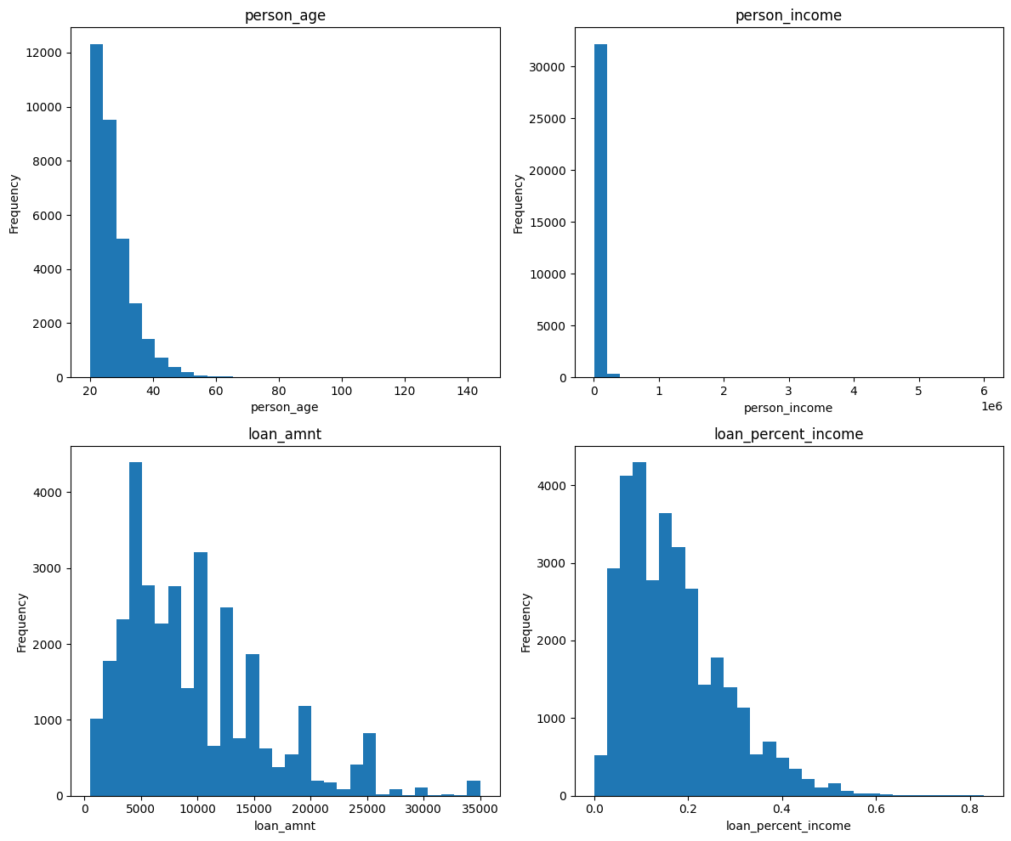
Figure 1. Distribution of key numerical variables, including borrower age, income, loan amount, and loan-to-income ratio

The age distribution is as shown in Figure 1; it is concentrated between 20 and 40 years and this means that most of the borrowers are part of a younger working population. Income distribution is extremely right skewed, with the majority of the people having a low to moderate income and some extreme high-income values, indicating income inequality among the sample.

4.2 Distribution of Loan Default Status
The distribution of loan status shows moderate class imbalance, with 78.18% non-default and 21.82% default cases (Table 2). This indicates that approximately one in five borrowers defaults, reflecting a notable level of credit risk within the data.

Table 2. Distribution of loan status
Loan status | Frequency | Percentage
Non-default (0) | 25,473 | 78.18
Default (1) | 7,108 | 21.82

This distribution highlights that default risk is a persistent issue rather than a rare occurrence, making it suitable for meaningful comparative analysis. The moderate imbalance also aligns with existing literature, which suggests that real-world credit datasets often exhibit similar patterns and require careful analytical handling to avoid biased conclusions (Alvi et al., 2024). Figure 2 further confirms that non-default cases dominate the dataset, although the presence of a substantial default proportion underscores the importance of effective risk prediction models.

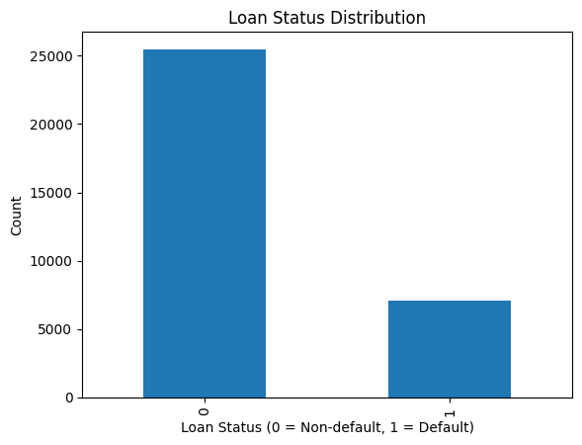
Figure 2. Distribution of loan status showing the proportion of non-default and default borrowers

As indicated in Figure 2, most borrowers fall under non-default category with a smaller percentage comprising the cases of defaults. This shows that there is a moderate level of class imbalance in the data with the non-default cases far exceeding the number of defaults.

4.3 Comparison of Numerical Variables by Loan Status
Comparison of mean values reveals significant differences between default and non-default borrowers. Default borrowers have lower mean income (49,125.65 vs. 70,804.36) and shorter employment duration (4.14 vs. 4.97 years), while exhibiting higher loan amounts (10,850.50 vs. 9,237.46), higher interest rates (13.06 vs. 10.44), and higher loan-to-income ratios (0.25 vs. 0.15). Age and credit history length show minimal differences (Table 3).

Table 3. Mean comparison of numerical variables by loan status

Variable | Non-default (0) Mean | Default (1) Mean
Borrower Age (years) | 27.81 | 27.47
Annual Income (USD) | 70,804.36 | 49,125.65
Employment Length (years) | 4.97 | 4.14
Loan Amount (USD) | 9,237.46 | 10,850.50
Interest Rate (%) | 10.44 | 13.06
Loan-to-Income Ratio | 0.15 | 0.25
Credit History Length (years) | 5.84 | 5.69

These patterns clearly indicate that borrowers with higher financial burden and lower repayment capacity are more likely to default. The findings emphasize that affordability and financial stability are critical determinants of creditworthiness. This aligns with previous studies demonstrating that income levels and employment stability are strong predictors of loan repayment behavior (Khemakhem & Boujelbene, 2018). Correlation analysis further supports these findings, showing positive associations between loan-to-income ratio (0.379), interest rate (0.335), and loan amount (0.105) with default risk, while income (-0.144) and employment length (-0.082) are negatively correlated (Table 4).

Table 4. Correlation of numerical variables with loan status

Variable | Correlation with Loan Status
Loan-to-Income Ratio | 0.379
Interest Rate (%) | 0.335
Loan Amount (USD) | 0.105
Credit History Length (years) | -0.016
Borrower Age (years) | -0.022
Employment Length (years) | -0.082
Annual Income (USD) | -0.144

This suggests that financial burden and cost of borrowing are the most influential factors in credit risk. Borrowers with higher debt relative to income face increased financial pressure, raising the likelihood of default. These results are consistent with prior research highlighting the predictive power of financial ratios and borrowing conditions in risk assessment (Khemakhem & Boujelbene, 2018; Alvi et al., 2024). Figure 3 further illustrates these differences, showing that default borrowers are concentrated in lower income groups and tend to take higher loan amounts. This reinforces the role of financial instability as a key driver of default risk.

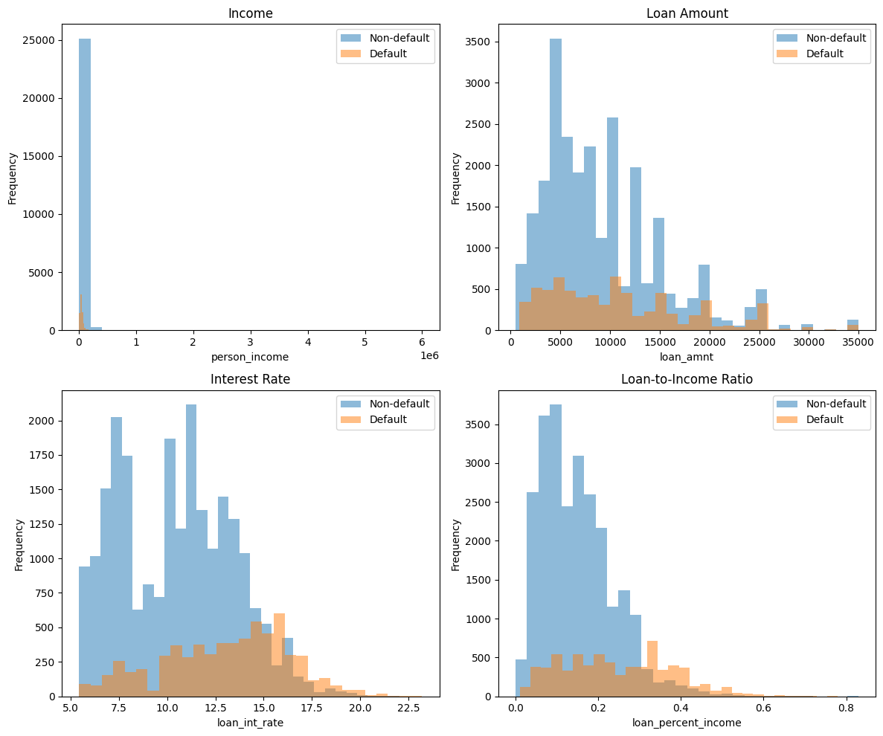
Figure 3. Comparative histogram overlays for default and non-default borrowers across major numerical variables, including income, loan amount, interest rate, and loan-to-income ratio

In Figure 3, it is evident that there exist significant differences between default and non-default borrowers in the key financial variables. The income distribution shows that the default borrowers are more concentrated in the low income and non- default borrowers are comparatively more represented in the higher income. However, the distribution of loan amount indicates that the default borrowers are more likely to borrow relatively higher amounts as compared to the non-default borrowers.

4.4 Categorical Risk Patterns
Categorical analysis reveals significant variation in default behavior across borrower groups, particularly in terms of home ownership, loan purpose, loan grade, and prior default history (Table 5).
Table 5: Default Rates Across Categorical Variables

Variable | Category | Default Rate (%)
Home Ownership | Rent | 31.57
Home Ownership | Other | 30.84
Home Ownership | Own | 7.47
Loan Purpose | Debt consolidation | 28.59
Loan Purpose | Medical | 26.70
Loan Purpose | Home improvement | 26.10
Loan Purpose | Venture | 14.81
Loan Grade | A | 9.96
Loan Grade | B | 16.28
Loan Grade | D | 59.05
Loan Grade | E | 64.42
Loan Grade | F | 70.54
Loan Grade | G | 98.44
Previous Default History | Yes (Y) | 37.81
Previous Default History | No (N) | 18.39

Borrowers with rental or non-ownership status exhibit higher default rates (31.57% and 30.84%) compared to homeowners (7.47%), indicating lower financial stability. Similarly, higher loan grades (D–G) show substantially elevated default rates (59.05% to 98.44%), while borrowers with prior default history are significantly more likely to default (37.81% vs. 18.39%). These findings highlight the importance of categorical variables in identifying high-risk borrower segments. The strong differentiation across loan grades and past default history confirms the continued relevance of traditional credit scoring systems. This is consistent with previous research demonstrating that historical credit performance is a reliable predictor of future default behavior (Kowsar, 2022).
Figure 4 supports these observations by illustrating that financially vulnerable groups such as renters and high-risk loan categories—exhibit higher default rates. Additionally, loan purpose influences risk, with debt consolidation and medical loans showing higher default rates compared to venture loans. These trends align with studies emphasizing the role of behavioral and categorical indicators in enhancing credit risk models.

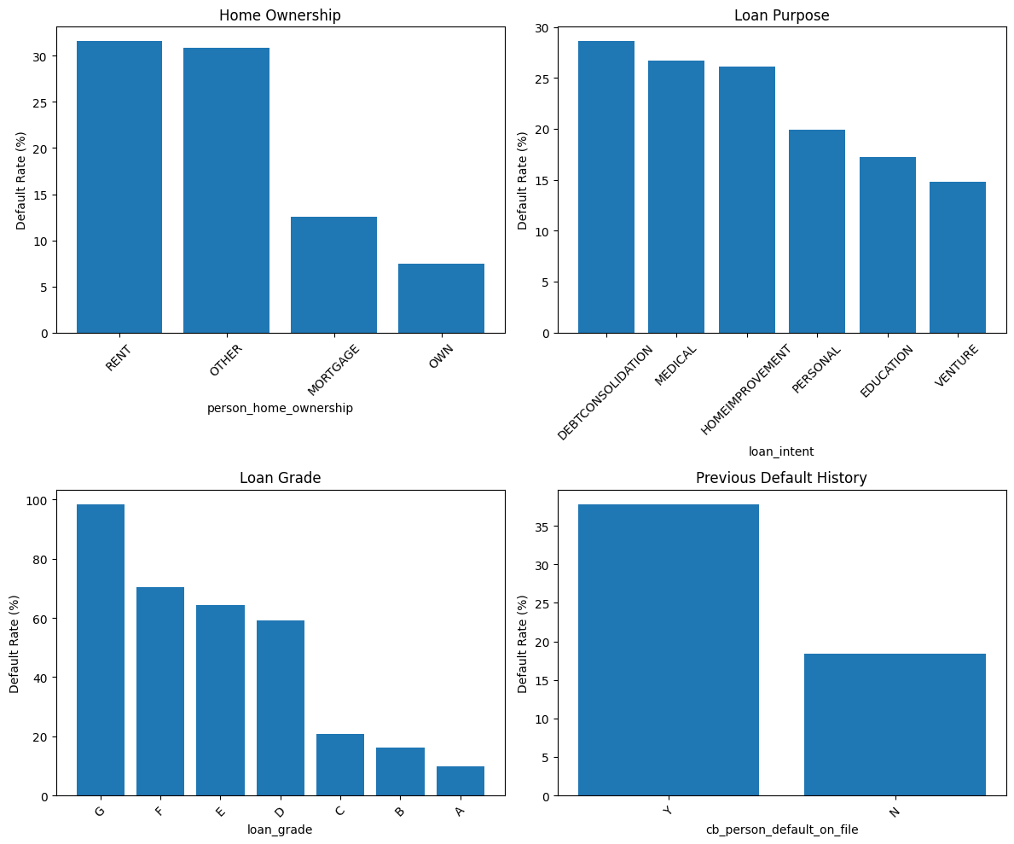
Figure 4. Multi-panel bar charts showing default rate by home ownership, loan intent, loan grade, and previous default on file

Borrowers with rental and other non-ownership statuses have a higher default rate than property owners as seen in Figure 4, which implies that they are not as financially stable as property owners. Loan purpose also indicates that there is a risk difference where debt consolidation and medical loans have high default rates whereas venture-related loans have low default rates.

4.5 Integrated Interpretation and Broader Implications
Overall, the results demonstrate that credit risk is influenced by a combination of financial capacity, borrowing behavior, and historical credit performance. Key variables such as loan-to-income ratio, interest rate, and income level play a dominant role in determining default risk. These findings reinforce the importance of structured financial data in capturing critical risk indicators.
The results are consistent with existing literature highlighting the effectiveness of predictive analytics in identifying key risk factors and improving financial resilience (Alvi et al., 2024; Aro, 2024). Furthermore, the findings support the growing adoption of artificial intelligence and big data analytics in credit risk management, as these technologies enhance predictive accuracy and decision-making efficiency (Paleti, 2024; Karami & Igbokwe, 2025).
From a practical perspective, financial institutions should prioritize key financial indicators such as loan-to-income ratio, interest rates, and income levels in their credit evaluation models. The integration of these variables with categorical indicators like loan grade and prior default history can significantly improve risk identification and reduce non-performing loans (Scott et al., 2024).
At a broader level, predictive analytics contributes to financial stability by enabling proactive risk management and improved forecasting. Previous studies have similarly demonstrated that advanced analytical methods enhance institutional resilience and operational efficiency (Uzzaman et al., 2021; Olaiya et al., 2024).
However, the study has certain limitations. The reliance on a single structured dataset may limit generalizability, while the absence of macroeconomic variables restricts the analysis of external influences. Additionally, the presence of outliers and missing values may affect accuracy. Future research should incorporate unstructured data and advanced hybrid models to enhance predictive performance (Jain et al., 2026). These directions align with emerging trends in smart finance, where AI-driven analytics play a central role in transforming credit risk management systems (Wah, 2025; Samson-Onuorah, 2025).

5. Conclusion
In this study, a predictive analytics model and a structured financial dataset were used to analyze credit risk management in the banking sector. The results indicate that important financial factors, especially loan to income ratio, interest rate, loan amount, and income level are significant in predicting the probability of loan default. The borrowers who had greater monetary load and lesser repayment ability were also observed to be more likely to default and the demographic variables like age had a comparatively insignificant impact. The analysis was also able to demonstrate that categorical factors like loan grade, home ownership status, purpose of loan, and past history of default perform quite well when it comes to differentiating high-risk from low-risk borrower groups. From these observations, it can be concluded that the use of a combination of numerical and categorical indicators should be considered while doing a proper analysis of credit risks. Generally, it was observed through this research study that the financial data collected in a structured manner can be used to do an analysis of credit risk and is a reliable source for understanding the behavior of potential borrowers. This approach allows banks to develop their capabilities in identifying future defaults and making proper lending decisions. By using such approaches in risk management, banks can be more efficient in assessing the credit worthiness of borrowers, reducing the number of non-performing assets, and achieving financial stability.

REFERENCES
- Addy, W. A., Ugochukwu, C. E., Oyewole, A. T., Ofodile, O. C., Adeoye, O. B., & Okoye, C. C. (2024). Predictive analytics in credit risk management for banks: A comprehensive review. GSC Advanced Research and Reviews, 18(2), 434-449.
- Adebayo, S. O. (2025). Data-Driven Credit Risk Management and Financial Stability in the Digital Era: Integrating Behavioral Analytics, FinTech Innovations, and Advanced Scoring Models. European Index Library of European International Journal of Multidisciplinary Research and Management Studies, 5(09), 53-58.
- Alsaadi, M., Almashhadany, M. T., Obaed, A. S., Furaijl, H. B., Kamil, S., & Ahmed, S. R. (2024, November). AI-based predictive analytics for financial risk management. In 2024 8th International Symposium on Multidisciplinary Studies and Innovative Technologies (ISMSIT) (pp. 1-7). IEEE.
- Alvi, J., Arif, I., & Nizam, K. (2024). Advancing financial resilience: A systematic review of default prediction models and future directions in credit risk management. Heliyon, 10(21).
- Amarnadh, V., & Moparthi, N. R. (2023). Comprehensive review of different artificial intelligence-based methods for credit risk assessment in data science. Intelligent Decision Technologies, 17(4), 1265-1282.
- Aro, O. E. (2024). Predictive analytics in financial management: enhancing decision-making and risk management. International Journal of Research Publication and Reviews, 5(10), 2181-2194.
- Bello, O. A. (2023). Machine learning algorithms for credit risk assessment: an economic and financial analysis. International Journal of Management, 10(1), 109-133.
- Dicuonzo, G., Galeone, G., Zappimbulso, E., & Dell'Atti, V. (2019). Risk management 4.0: The role of big data analytics in the bank sector. International Journal of Economics and Financial Issues, 9(6), 40-47.
- Jain, Y. K., Gupta, S. K., Alsekait, D. M., Albeshri, M. Y., & AbdElminaam, D. S. (2026). Enhanced Predictive Modeling for Financial Risk Assessment using Hybrid AI (ML & DL) on Structured and Unstructured Data.
- Karami, A., & Igbokwe, C. (2025). The impact of big data characteristics on credit risk assessment. International Journal of Data Science and Analytics, 20(5), 4239-4259.
- Khemakhem, S., & Boujelbene, Y. (2018). Predicting credit risk on the basis of financial and non-financial variables and data mining. Review of accounting and finance, 17(3), 316-340.
- Kowsar, M. M. (2022). A systematic review of credit risk assessment models in emerging economies: A focus on Bangladesh's commercial banking sector. American Journal of Advanced Technology and Engineering Solutions, 2(01), 01-31.
- Lao Tse. (2020). Credit risk dataset. Kaggle. Credit Risk Dataset on Kaggle
- Nahar, J., Hossain, M. S., Rahman, M. M., & Hossain, M. A. (2024). Advanced predictive analytics for comprehensive risk assessment in financial markets: Strategic applications and sector-wide implications. Global Mainstream Journal of Business, Economics, Development & Project Management, 3(4), 39-53.
- Nahar, J., Rahaman, M. A., Alauddin, M., & Rozony, F. Z. (2024). Big data in credit risk management: a systematic review of transformative practices and future directions. International Journal of Management Information Systems and Data Science, 1(04), 68-79.
- Nayak, S. (2024). Developing predictive models for financial stability: Integrating behavioral analytics into credit risk management. Journal of Artificial Intelligence & Cloud Computing, 3(5), 2-10.
- Olaiya, O. P., Cynthia, A. C., Usoro, S. O., Obani, O. Q., Nwafor, K. C., & Ajayi, O. O. (2024). The impact of big data analytics on financial risk management. International journal of science and research archive, 12(2), 821-827.
- Paleti, S. (2024). Transforming financial risk management with AI and data engineering in the modern banking sector. American Journal of Analytics and Artificial Intelligence (AJAAI), 1(1), 2-12.
- Roeder, J., Palmer, M., & Muntermann, J. (2022). Data-driven decision-making in credit risk management: The information value of analyst reports. Decision Support Systems, 158, 113770.
- Saad Bekhouche, H., Aissaoui, S., & Zied, D. (2025). The Impact of Big Data Analytics Using Artificial Intelligence on Financial Risk Management An Applied Study on the National Popular Credit Bank (CPA) Using Structura. مجلة العلوم الإدارية والمالية, 9(2), 84-99.‎
- Samson-Onuorah, C. I. (2025). AI-driven Credit Risk Modeling: Leveraging Big Data Analytics to Improve Financial Stability and Lending Efficiency in Banks. Int J Sci Eng Appl, 14(10), 57-70.
- Scott, A. O., Amajuoyi, P., & Adeusi, K. B. (2024). Advanced risk management solutions for mitigating credit risk in financial operations. Magna Scientia Advanced Research and Reviews, 11(1), 212-223.
- Shrivastava, G., Jain, V., & Victor, G. J. (2024). Credit Risk Identification and Prevention Strategies in Small and Medium Banks Using Big Data Techniques.
- Uzzaman, A., Kudapa, S. P., & Nijhum, A. M. (2021). Predictive Analytics For Improving Financial Forecasting And Risk Management In US Capital Markets. American Journal of Interdisciplinary Studies, 2(04), 69-100.
- Wah, J. N. K. (2025). Smart Finance Unleashed: AI-Driven Predictive Analytics and Risk Management in Finance. Journal of Hunan University Natural Sciences, 52(5).

